 | Sanjivani Rural Educational Society’s  SANJIVANI COLLEGE OF ENGINEERING  (An Autonomous Institution)  Kopargaon – 423 603, Maharashtra. | ACAD-F-14 B
Academic Year: 2026-2027 | CIA ACTIVITY REPORT | Revision : 00
Department : | Computer Engineering | Date of Preparation : 10/10/2026
Course Code & Name: | PCCO301-Theory of Computation | Year/Sem: TY Sem-I

Activity Title: Parentheses Matching using Turing Machine

Submitted by:
Roll No | PRN No | Name of the Student | Signature
131 | 0124UCSM1131 | Bharat Shelke
133 | 0124UCSM1133 | Shyam Amte
134 | 0124UCSM1134 | Vaibhav Dawange
135 | 0124UCSM1135 | Uday Gadekar

Course Incharge
DR.N.G.Pardeshi

CIA REPORT INDEX

Chapter | Title | Page No.
Chapter 1 | Abstract | 3
Chapter 2 | Problem Definition | 4
Chapter 3 | Introduction | 6
Chapter 4 | System Architecture and Design | 8
Chapter 5 | Methodology or Algorithms | 11
Chapter 6 | Experimental Results | 14
Chapter 7 | Conclusion | 18
Chapter 8 | References | 19
Annexure A | GitHub Upload Snapshot | 20
Annexure B | Presentation Geotag Photograph | 21

Chapter 1: Abstract
Balanced parentheses are fundamental to the correct syntax of programming languages and mathematical expressions. Every compiler, assembler front end and macro processor studied in System Software must be able to decide whether the brackets in its input are properly opened and closed before any further translation can take place. This case study designs and implements a deterministic, single-tape Turing Machine (TM) that decides whether an input string over the alphabet { ( , ) } is balanced.
The machine works by repeated marking. It scans the tape from left to right until it meets the first unmarked closing parenthesis and overwrites it with the mark Y. It then moves its head to the left, finds the nearest unmarked opening parenthesis, overwrites it with the mark X, and returns to the right to continue scanning. If a closing parenthesis is found with no opening parenthesis available on its left, or if an unmarked opening parenthesis remains when the tape is exhausted, the machine halts in the reject state qR. Otherwise it halts in the accept state qA.
The design uses five states (q0, q1, q2, qA, qR), five tape symbols ( ( , ) , X, Y and the blank ) and thirteen transitions. The machine was simulated with a Python program that records every step, so that tape marking, head movement and state transitions can all be demonstrated. It was tested on sixteen hand-chosen strings and then exhaustively on all 8,191 strings of length 0 to 12 over { ( , ) }, and its answer agreed with an independent reference checker in every case. The step count grows as 2(n+1)² in the worst case (nested parentheses with n pairs) and as 6n + 2 for flat strings such as ()()(), which agrees with the quadratic time bound expected from a single-tape machine.
Keywords: Turing Machine, balanced parentheses, tape marking, state transition, Dyck language, System Software.

Chapter 2: Problem Definition

2.1 Background and Motivation
A programming language statement such as if ((a + b) * (c - d)) > 0 is meaningful only when every opening bracket has a matching closing bracket in the correct order. Compilers check this during syntax analysis, assemblers check it while evaluating address expressions, and macro processors must check it while expanding nested macro calls. A failure to detect an unbalanced expression leads to wrong code or a meaningless error message, so a precise and provably correct bracket-checking procedure is a basic building block of System Software.
The Turing Machine is the standard mathematical model of an algorithm. Expressing the bracket-matching procedure as a Turing Machine removes every implementation convenience (stacks, counters, recursion) and shows exactly which operations are needed: reading a symbol, writing a mark, moving the head and changing state.

2.2 Problem Statement
Balanced parentheses are essential for the correct syntax of programming languages and mathematical expressions. Students are required to design a Turing Machine that determines whether an input string contains correctly balanced parentheses. The TM should repeatedly match opening and closing parentheses by marking processed symbols until the tape is exhausted. If every opening parenthesis has a matching closing parenthesis in the correct order, the machine should accept; otherwise, it should reject. The implementation must demonstrate tape marking, head movement, and state transitions.

2.3 Objectives
- To design a deterministic single-tape Turing Machine that recognises the language of balanced parentheses.
- To use marking symbols so that every processed parenthesis is visibly recorded on the tape.
- To demonstrate tape marking, head movement and state transitions through a step-by-step execution trace.
- To verify the machine on valid and invalid inputs and against an independent reference checker.
- To analyse the time and space requirements of the machine.

2.4 Formal Definition of the Language
Let Σ = { ( , ) }. The language B of balanced strings is the smallest set of strings satisfying three rules: (i) the empty string ε belongs to B; (ii) if w belongs to B, then (w) belongs to B; (iii) if u and v belong to B, then uv belongs to B. Equivalently, a string is balanced if and only if every prefix contains at least as many opening as closing parentheses, and the whole string contains equally many of each. For example, ε, (), (()) and ()(()) are balanced, whereas (, ), )( and (() are not.

2.5 Input and Output Specification
Table 2.1: Input and output specification of the machine
Item | Specification
Input | A string of length n ≥ 0 over { ( , ) } written on the tape, one symbol per cell; all other cells are blank (_).
Initial configuration | State q0, head on the leftmost input symbol.
Output | Halting state: qA means the string is balanced (ACCEPT); qR means it is not (REJECT).
Illegal symbols | Any symbol outside { ( , ) } has no transition, so the machine rejects.
Empty input | The empty string is balanced and is accepted.

2.6 Scope, Assumptions and Constraints
- Only one type of bracket, the round parenthesis, is handled; other bracket types are discussed as future work.
- The machine is deterministic and uses a single tape that is infinite in both directions.
- The tape alphabet may be extended with marking symbols; the input itself is never copied elsewhere.
- The result is a yes/no decision; the machine does not report the position of an error.

Chapter 3: Introduction

3.1 Bracket Checking in System Software
System Software translates and manages programs. In a compiler, the lexical analyser breaks the source into tokens and the parser then checks that the tokens follow the grammar of the language [5]. Nested constructs such as parenthesised expressions, blocks and function calls are checked in this phase. In macro processors, nested macro definitions and calls follow the same last-opened, first-closed discipline [6]. The common structure behind all of these is the matching of opening and closing symbols in the correct order.

3.2 The Turing Machine Model
A Turing Machine, introduced by Alan Turing in 1936 [3], consists of a finite control, an unbounded tape divided into cells, and a read/write head. In each step the machine reads the symbol under the head, writes a symbol, moves the head one cell to the left or right, and changes state. Formally, a TM is a 7-tuple M = (Q, Σ, Γ, δ, q0, B, F) [1], where Q is the finite set of states, Σ the input alphabet, Γ the tape alphabet containing Σ and the blank B, δ : Q × Γ → Q × Γ × {L, R} the transition function, q0 the start state and F the set of accepting states.
A string is accepted if the machine reaches an accepting state, and rejected if it reaches a rejecting state or has no applicable transition. A machine that halts on every input, as the one in this report does, is called a decider [2].

3.3 Why a Turing Machine for Parentheses?
The language of balanced parentheses is not regular. By the pumping lemma, if it were regular then in the string (ᵖ)ᵖ, which has p opening parentheses followed by p closing ones, the pumped part would lie inside the opening parentheses, and repeating it would give more opening than closing parentheses, a string that is not balanced. A finite automaton therefore cannot recognise the language because it has no unbounded memory. A pushdown automaton can do so with a stack that holds the pending opening parentheses.
A Turing Machine has no separate stack. Its tape is its only memory, so the pending opening parentheses and the progress of matching must both be recorded on the tape itself. This is done by overwriting processed symbols with marks. The exercise therefore shows how the tape, the head and the state work together to replace a stack.

3.4 The Marking Technique
The machine pairs each closing parenthesis with the nearest unmatched opening parenthesis on its left. When a closing parenthesis is found it is overwritten by Y, and when its partner is found it is overwritten by X. Marked cells are skipped in later passes. When no unmarked closing parenthesis remains, the tape must contain no unmarked opening parenthesis either; otherwise some opening parenthesis was never matched.

3.5 Organisation of the Report
Chapter 1 gives the abstract and Chapter 2 defines the problem. Chapter 3 is this introduction. Chapter 4 presents the architecture and the formal design of the machine, including the state diagram and transition table. Chapter 5 explains the algorithm, its correctness and its complexity. Chapter 6 reports the experimental results, including full execution traces. Chapter 7 concludes the report and Chapter 8 lists the references. Annexure A holds the GitHub upload snapshot and Annexure B the geotagged photograph of the presentation.

Chapter 4: System Architecture and Design

4.1 Overview of the Architecture
The system follows the classical Turing Machine architecture shown in Figure 4.1. The input string is loaded onto the tape. The read/write head reads the symbol under it and passes the symbol to the finite control. The finite control looks up the current state and symbol in the transition table δ, and returns the symbol to write, the direction to move and the next state. The machine halts in qA or qR.
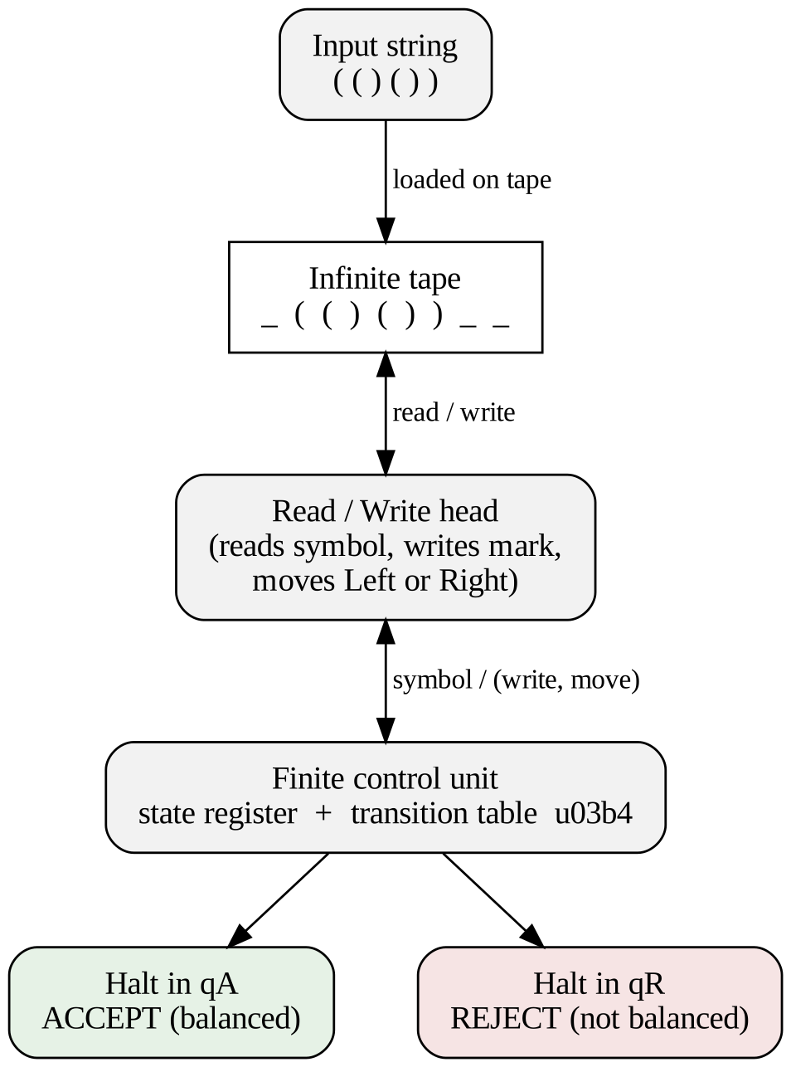
Figure 4.1: Architecture of the parentheses-matching Turing Machine

4.2 Formal Specification
The machine is M = (Q, Σ, Γ, δ, q0, B, F) with the following components.
- Q = { q0, q1, q2, qA, qR }
- Σ = { ( , ) }
- Γ = { ( , ) , X, Y, _ } where _ is the blank symbol B
- Start state = q0; accepting state F = { qA }; qR is the rejecting halt state
- δ is given in Table 4.3 and has 13 transitions.

4.3 Tape Alphabet
Table 4.1: Tape symbols and their roles
Symbol | Meaning | Role in the machine
( | Opening parenthesis | Input symbol; waits to be matched
) | Closing parenthesis | Input symbol; triggers a matching pass
X | Matched opening parenthesis | Mark written over a ( that has been paired
Y | Matched closing parenthesis | Mark written over a ) that has been paired
_ | Blank | Marks the left and right ends of the input

4.4 States
Table 4.2: States of the machine
State | Name | Purpose
q0 | Scan right | Moves right over (, X and Y to find the next unmarked ) or the right end
q1 | Return left | Moves left over X and Y to find the nearest unmarked ( to pair with the ) just marked
q2 | Final check | At the right end, sweeps left to confirm that no unmarked ( is left
qA | Accept | Halting state: the string is balanced
qR | Reject | Halting state: the string is not balanced

4.5 Transition Function
Table 4.3: Transition function δ (read / write, move, next state)
No. | State | Read | Write | Move | Next | Action
1 | q0 | ( | ( | R | q0 | Skip opening parenthesis
2 | q0 | X | X | R | q0 | Skip matched opening
3 | q0 | Y | Y | R | q0 | Skip matched closing
4 | q0 | ) | Y | L | q1 | Mark closing, look for partner
5 | q0 | _ | _ | L | q2 | Right end reached, check
6 | q1 | X | X | L | q1 | Skip matched opening
7 | q1 | Y | Y | L | q1 | Skip matched closing
8 | q1 | ( | X | R | q0 | Mark partner, resume scan
9 | q1 | _ | _ | R | qR | No partner: reject
10 | q2 | X | X | L | q2 | Skip matched opening
11 | q2 | Y | Y | L | q2 | Skip matched closing
12 | q2 | ( | ( | R | qR | Unmatched ( found: reject
13 | q2 | _ | _ | R | qA | All matched: accept

4.6 State Transition Diagram
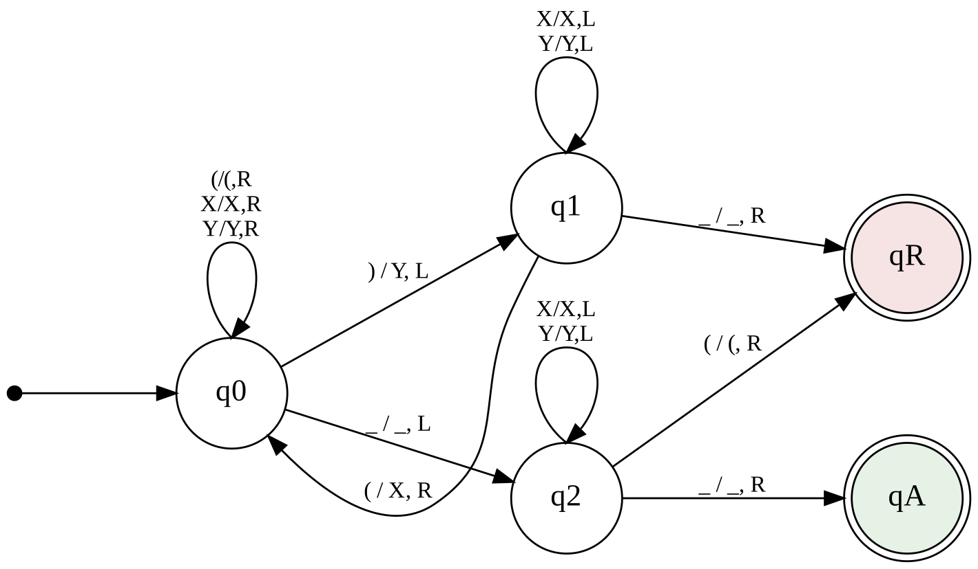
Figure 4.2: State transition diagram (edge label: read / write, move)

4.7 Design Decisions
- Two different marks. X and Y are kept distinct so that the tape records both which opening and which closing parentheses have been paired, which makes execution traces easy to read.
- Blank on the left. The blank to the left of the input lets q1 detect that no partner exists, so a surplus closing parenthesis is rejected at once (transition 9).
- Final sweep in q2. After the last closing parenthesis has been matched, state q2 checks that no unmarked opening parenthesis remains (transition 12).
- Implicit rejection. A pair of state and symbol with no entry in δ, such as an illegal character, sends the machine to qR.

Chapter 5: Methodology or Algorithms

5.1 Matching Strategy
The method is a repeated pairing procedure. Each pass handles one closing parenthesis: the leftmost unmarked closing parenthesis is paired with the nearest unmarked opening parenthesis on its left. Because the scan always stops at the leftmost unmarked closing parenthesis, every cell to the left of the head holds either an unmarked ( or a mark, and the nearest unmarked ( is always the correct partner.

5.2 Algorithm
- Place the input on the tape between two blanks. Set the head on the first input symbol and the state to q0.
- In q0, move right over (, X and Y until an unmarked ) or a blank is read.
- If ) is read, overwrite it with Y, move left and enter q1.
- In q1, move left over X and Y until ( or a blank is read.
- If ( is read, overwrite it with X, move right and return to q0 (step 2). If a blank is read, no partner exists: halt in qR.
- If a blank is read in q0, the right end has been reached. Move left and enter q2.
- In q2, move left over X and Y. If ( is read, an opening parenthesis was never matched: halt in qR. If the blank at the left end is reached, halt in qA.

5.3 Flowchart
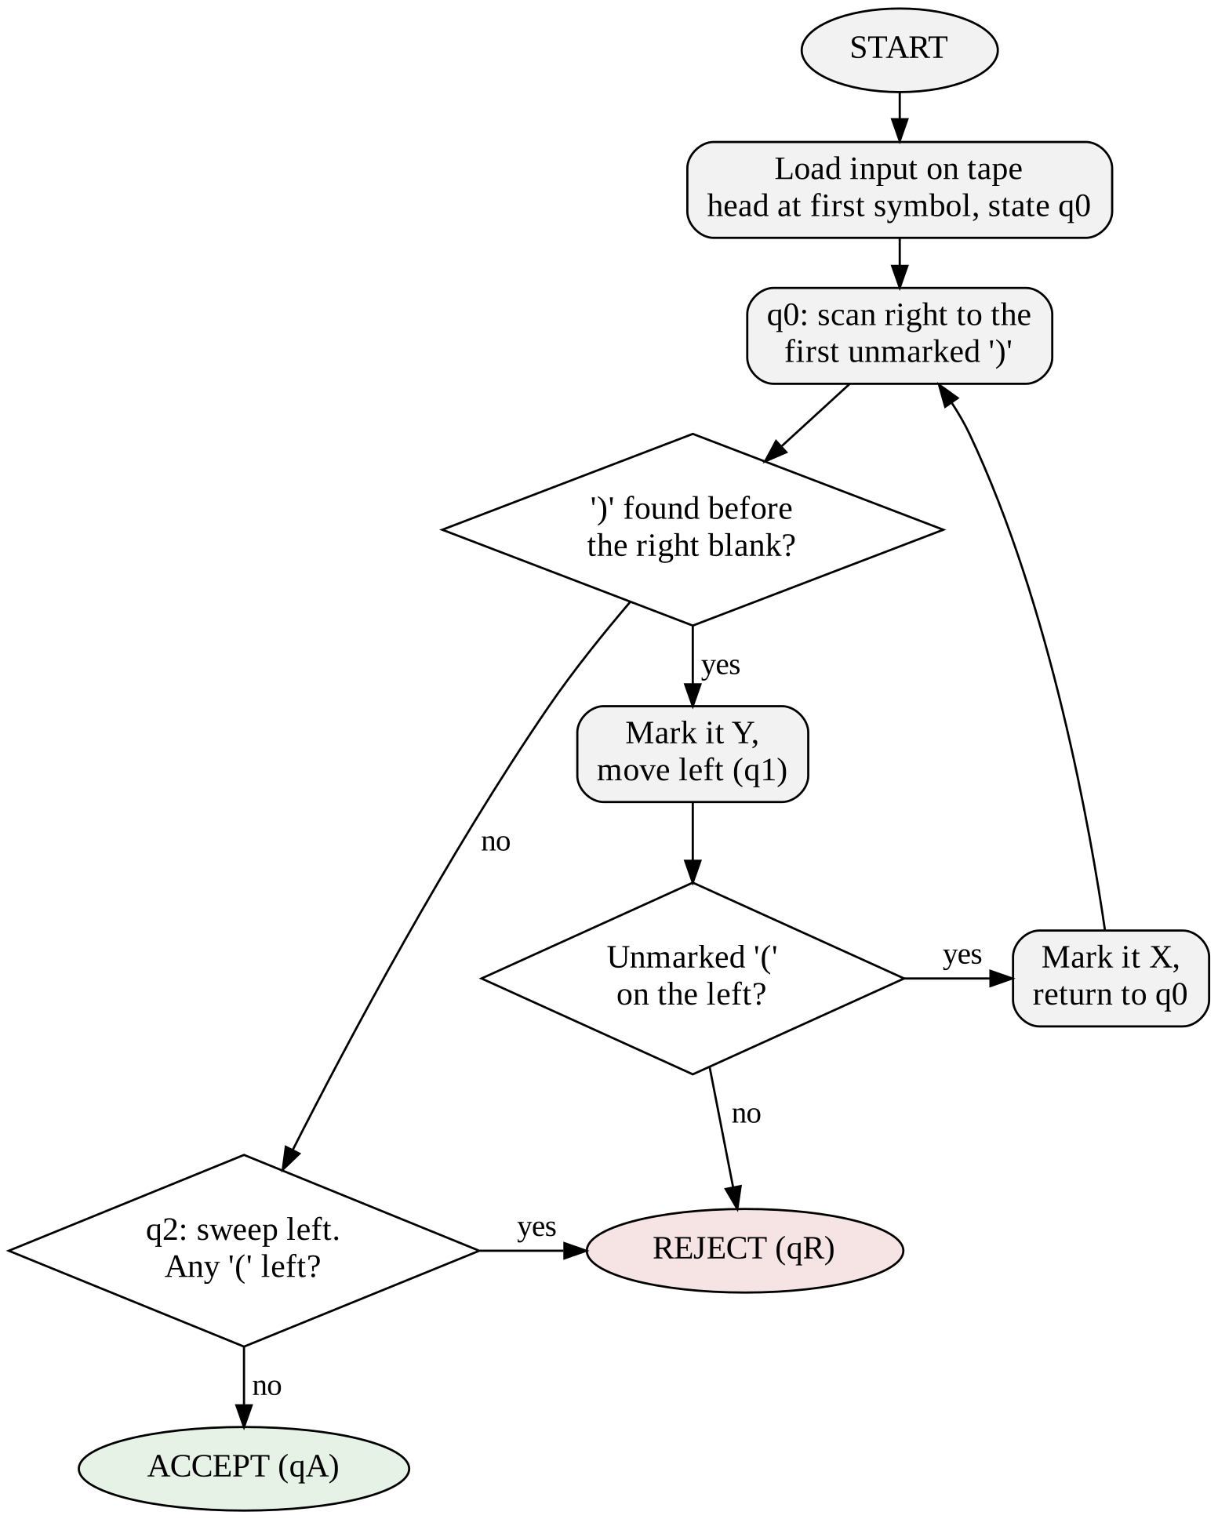
Figure 5.1: Flowchart of the parentheses-matching algorithm

5.4 Tape Marking, Head Movement and State Changes
Tape marking. Marking is the only form of memory the machine has. Writing Y over ) records that the closing parenthesis has been consumed and writing X over ( records that its partner has been consumed. Marks are never erased, so at any moment the tape shows exactly how far the matching has progressed.
Head movement. The head makes a rightward sweep in q0 to find the next closing parenthesis and a leftward sweep in q1 to find its partner. The final leftward sweep in q2 verifies that nothing is left over. The head therefore moves back and forth across the already marked region, which is what makes the running time quadratic.
State transitions. q0 and q1 alternate once for every closing parenthesis. The change from q0 to q2 happens only when the right-hand blank is read, and q2 decides between qA and qR.

5.5 Correctness Argument
Each time the machine enters q0, the following invariant holds: the number of X marks equals the number of Y marks, each Y is paired with exactly one X to its left, and every unmarked symbol to the left of the head is an opening parenthesis. The invariant holds initially because nothing is marked. A pass through q0 and q1 either marks one new pair, which preserves the invariant, or halts in qR because a ) has no partner, in which case some prefix has more closing than opening parentheses and the string is indeed not balanced.
When q0 reaches the right blank, all closing parentheses are paired. The string is balanced exactly when no unmarked ( remains, which is what q2 checks. Since every pass marks at least one cell, the machine halts on every input after a finite number of steps.

5.6 Complexity Analysis
Space. The machine only overwrites the input cells and the two blank end cells, so it uses n + 2 cells, that is O(n).
Time. Each of the at most n/2 passes sweeps across a marked region of length up to n, so the worst-case time is O(n²). The experiments in Chapter 6 give the exact counts: 2(n+1)² steps for n nested pairs and 6n + 2 steps for n flat pairs. For an input of length L = 2n the worst case is L²/2 + 2L + 2 steps. A single-tape Turing Machine cannot do better than a quadratic bound for this language [4].

5.7 Implementation
The machine was implemented in Python 3 (file tm_parentheses.py). The transition table δ is a dictionary keyed by (state, symbol), and the tape is a list with a blank at each end. The core simulation loop is shown below; the complete program is available in the GitHub repository shown in Annexure A.
def run(text, trace=False):
tape = [BLANK] + list(text) + [BLANK]
head, state, steps = 1, 'q0', 0
while state not in ('qA', 'qR'):
symbol = tape[head]
if (state, symbol) not in DELTA: # illegal symbol
state = 'qR'; break
write, move, nxt = DELTA[(state, symbol)]
tape[head] = write # tape marking
head += 1 if move == 'R' else -1 # head movement
state = nxt # state transition
steps += 1
return state == 'qA', steps

Chapter 6: Experimental Results

6.1 Experimental Setup
The machine was executed on a Python 3 simulator that follows the transition table of Table 4.3 exactly. The simulator records, for every step, the state, the head position, the symbol read, the symbol written, the direction of movement, the next state and the contents of the tape. Results were checked against an independent reference checker that counts the nesting depth of the string. In the traces, the cell under the head is shown in square brackets and positions are numbered from 0 for the left blank.

6.2 Test Cases
Table 6.1: Results on sample inputs
Input | Expected | TM output | Steps | Result
ε (empty) | Balanced | ACCEPT | 2 | Pass
() | Balanced | ACCEPT | 8 | Pass
(()) | Balanced | ACCEPT | 18 | Pass
()() | Balanced | ACCEPT | 14 | Pass
(()()) | Balanced | ACCEPT | 28 | Pass
((())) | Balanced | ACCEPT | 32 | Pass
(()(())) | Balanced | ACCEPT | 42 | Pass
()(())() | Balanced | ACCEPT | 30 | Pass
( | Not balanced | REJECT | 3 | Pass
) | Not balanced | REJECT | 2 | Pass
)( | Not balanced | REJECT | 2 | Pass
(() | Not balanced | REJECT | 9 | Pass
()) | Not balanced | REJECT | 8 | Pass
())( | Not balanced | REJECT | 8 | Pass
((()) | Not balanced | REJECT | 19 | Pass
(()))( | Not balanced | REJECT | 18 | Pass

All sixteen inputs were classified correctly. The results include balanced strings with nesting, with concatenation and with both, and unbalanced strings with a missing closing parenthesis, a missing opening parenthesis, a wrong order and a surplus closing parenthesis.

6.3 Execution Trace of an Accepted Input
Table 6.2 shows the full execution of the machine on the input (()). It demonstrates the three required features: the tape marking (X and Y appear in the tape column), the head movement (the position changes by one cell per step), and the state transitions (q0 → q1 → q0 → q1 → q0 → q2 → qA).
Table 6.2: Step-by-step trace for the input (())
Step | State | Pos | Read | Write | Move | Next | Tape before step
1 | q0 | 0 | ( | ( | R | q0 | _ [(] ( ) ) _
2 | q0 | 1 | ( | ( | R | q0 | _ ( [(] ) ) _
3 | q0 | 2 | ) | Y | L | q1 | _ ( ( [)] ) _
4 | q1 | 1 | ( | X | R | q0 | _ ( [(] Y ) _
5 | q0 | 2 | Y | Y | R | q0 | _ ( X [Y] ) _
6 | q0 | 3 | ) | Y | L | q1 | _ ( X Y [)] _
7 | q1 | 2 | Y | Y | L | q1 | _ ( X [Y] Y _
8 | q1 | 1 | X | X | L | q1 | _ ( [X] Y Y _
9 | q1 | 0 | ( | X | R | q0 | _ [(] X Y Y _
10 | q0 | 1 | X | X | R | q0 | _ X [X] Y Y _
11 | q0 | 2 | Y | Y | R | q0 | _ X X [Y] Y _
12 | q0 | 3 | Y | Y | R | q0 | _ X X Y [Y] _
13 | q0 | 4 | _ | _ | L | q2 | _ X X Y Y [_]
14 | q2 | 3 | Y | Y | L | q2 | _ X X Y [Y] _
15 | q2 | 2 | Y | Y | L | q2 | _ X X [Y] Y _
16 | q2 | 1 | X | X | L | q2 | _ X [X] Y Y _
17 | q2 | 0 | X | X | L | q2 | _ [X] X Y Y _
18 | q2 | -1 | _ | _ | R | qA | [_] X X Y Y _

6.4 Tape Marking Snapshots
Figure 6.1 shows the tape at selected steps of the same run. The thick border is the cell under the head. The pair of innermost parentheses is marked first (steps 3 and 4), then the outer pair (steps 6 to 9), and finally the sweep in q2 confirms that no unmarked ( is left.
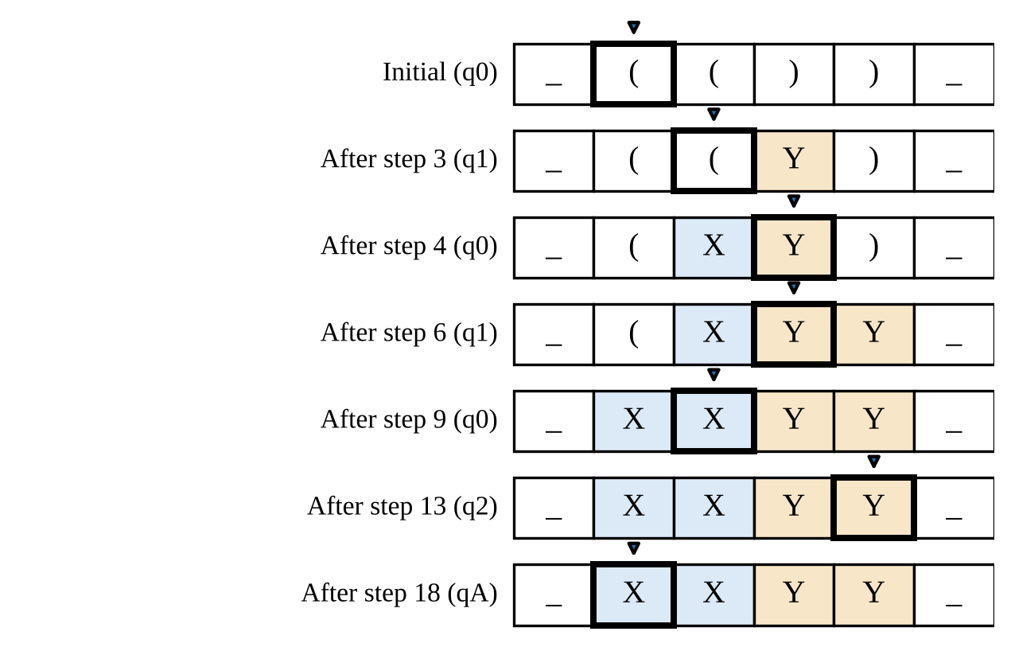
Figure 6.1: Tape snapshots while processing (())

6.5 Execution Trace of a Rejected Input
Table 6.3 shows the input ()), which has one closing parenthesis too many. The first pair is matched in steps 1 to 3. The second ) is marked in step 5, but the leftward search in q1 passes only marks and reaches the left blank, so the machine halts in qR at step 8.
Table 6.3: Step-by-step trace for the input ())
Step | State | Pos | Read | Write | Move | Next | Tape before step
1 | q0 | 0 | ( | ( | R | q0 | _ [(] ) ) _
2 | q0 | 1 | ) | Y | L | q1 | _ ( [)] ) _
3 | q1 | 0 | ( | X | R | q0 | _ [(] Y ) _
4 | q0 | 1 | Y | Y | R | q0 | _ X [Y] ) _
5 | q0 | 2 | ) | Y | L | q1 | _ X Y [)] _
6 | q1 | 1 | Y | Y | L | q1 | _ X [Y] Y _
7 | q1 | 0 | X | X | L | q1 | _ [X] Y Y _
8 | q1 | -1 | _ | _ | R | qR | [_] X Y Y _

6.6 Exhaustive Verification
To check that the machine is correct for every input of reasonable size, it was run on every one of the 2^L strings of each length L from 0 to 12 over { ( , ) }, which is 8,191 strings in total. Its answer was compared with the reference checker. No disagreement was found. The number of strings accepted at each even length equals the Catalan number C(L/2) (1, 1, 2, 5, 14, 42, 132), which is the known count of balanced strings, and no string of odd length was accepted.
Table 6.4: Exhaustive test over all strings of length 0 to 12
Length | Strings tested | Balanced (reference) | Accepted by TM | Mismatches
0 | 1 | 1 | 1 | 0
2 | 4 | 1 | 1 | 0
4 | 16 | 2 | 2 | 0
6 | 64 | 5 | 5 | 0
8 | 256 | 14 | 14 | 0
10 | 1024 | 42 | 42 | 0
12 | 4096 | 132 | 132 | 0
0–12 (all) | 8191 | 197 | 197 | 0

6.7 Running Time
Figure 6.2 plots the number of steps against the number of parenthesis pairs n. For the nested input ((...)) the k-th match requires the head to travel about 2k cells, so the total is exactly 2(n+1)² steps for every n from 1 to 60. For the flat input ()()...() each pair is matched in a constant number of steps and the total is exactly 6n + 2 steps. The nested input is therefore the worst case, with quadratic growth, and the flat input the best case, with linear growth.
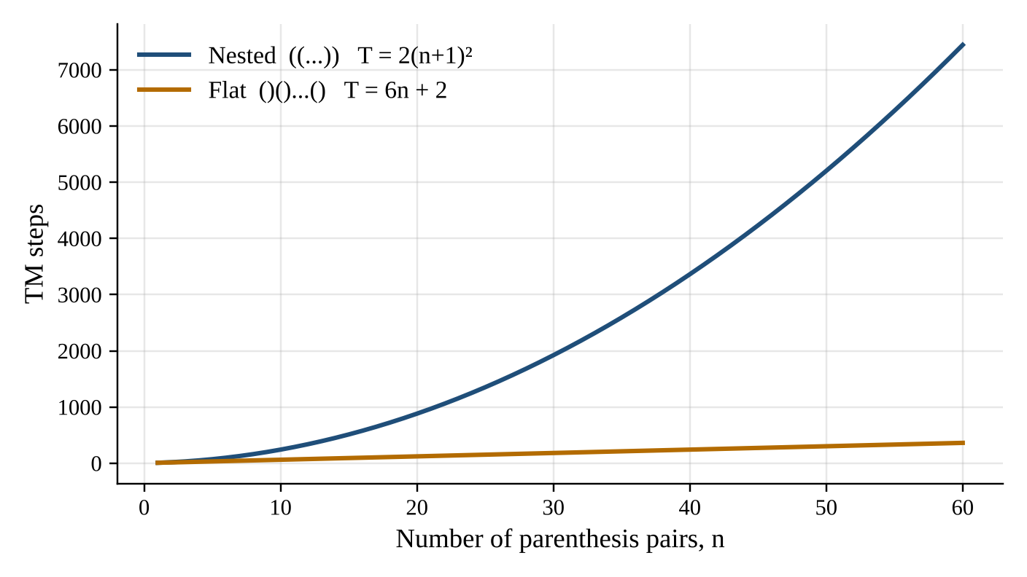
Figure 6.2: Number of TM steps versus number of parenthesis pairs

6.8 Discussion
- The machine accepted every balanced string and rejected every unbalanced one in all tests.
- Rejection occurs early for a surplus closing parenthesis (in q1) and late for a surplus opening parenthesis (in q2), because the latter can be detected only after the whole tape has been scanned.
- The quadratic cost comes from the repeated sweeps of the head across the marked region, which is the price of using the tape as the only memory.

Chapter 7: Conclusion
A deterministic single-tape Turing Machine with five states, five tape symbols and thirteen transitions was designed to decide whether a string of parentheses is balanced. The machine pairs each closing parenthesis with the nearest unmatched opening parenthesis by overwriting both with marks, and it decides acceptance by a final sweep that looks for unmarked opening parentheses.
The simulation demonstrated tape marking, head movement and state transitions in complete execution traces. The machine agreed with an independent reference checker on all 8,191 strings of length up to 12, and on the sixteen sample inputs. It needs O(n) tape cells and O(n²) steps in the worst case, with exactly 2(n+1)² steps for n nested pairs and 6n + 2 steps for n flat pairs.

7.1 Limitations
- Only the round parenthesis is handled, and the machine reports only accept or reject, not the position of the error.
- The results are from a software simulation; the correctness argument covers all lengths but the exhaustive test covers lengths up to 12.

7.2 Future Scope
- Extend the machine to several bracket types such as (), [] and {} by using one pair of marks for each type.
- Use a multi-tape machine to bring the running time down to linear, and add error position reporting.
- Relate the machine to the expression-checking stage of a compiler or macro processor built in the System Software course.

Chapter 8: References
[1] J. E. Hopcroft, R. Motwani and J. D. Ullman, Introduction to Automata Theory, Languages, and Computation, 3rd ed. Boston, MA, USA: Pearson Addison-Wesley, 2006.
[2] M. Sipser, Introduction to the Theory of Computation, 3rd ed. Boston, MA, USA: Cengage Learning, 2012.
[3] A. M. Turing, “On computable numbers, with an application to the Entscheidungsproblem,” Proceedings of the London Mathematical Society, series 2, vol. 42, pp. 230–265, 1936.
[4] P. Linz, An Introduction to Formal Languages and Automata, 6th ed. Burlington, MA, USA: Jones & Bartlett Learning, 2016.
[5] A. V. Aho, M. S. Lam, R. Sethi and J. D. Ullman, Compilers: Principles, Techniques, and Tools, 2nd ed. Boston, MA, USA: Pearson Addison-Wesley, 2006.
[6] D. M. Dhamdhere, Systems Programming and Operating Systems, 2nd rev. ed. New Delhi, India: Tata McGraw-Hill, 1999.
[7] L. L. Beck, System Software: An Introduction to Systems Programming, 3rd ed. Boston, MA, USA: Addison-Wesley, 1997.
[8] Python Software Foundation, “Python 3 Documentation.” [Online]. Available: https://docs.python.org/3/

Annexure A: GitHub Upload Snapshot
Snapshot of the GitHub repository in which the program (tm_parentheses.py), the report and the supporting files of this case study were uploaded.

Repository name
Repository URL
Date of upload

Annexure B: Presentation Geotag Photograph
Geotagged photograph taken during the presentation of this case study.

Place of presentation
Date and time
Latitude and longitude

